# COMS-280 Final Project Complete Code and Outputs

## **Code:**

#include <iostream>

#include <list>

#include <memory>

#include <iomanip>

#include <sstream>

#include <stdexcept>

#include <functional>

using namespace std;

/**

* Template function for calculating a percentage.

* Supports generic numeric types for financial computations.

*/

template <typename T>

T calculatePercentage(T value, T rate) {

return value * (rate / static_cast<T>(100));

}

/**

* Utility class to handle interest calculation for savings accounts.

* Uses the generic percentage template.

*/

class InterestCalculator {

public:

static double calculateInterest(double balance, double rate) {

return calculatePercentage(balance, rate);

}

};

/**

* Utility class to enforce overdraft rules in checking accounts.

*/

class OverdraftProtection {

public:

static bool canWithdraw(double balance, double overdraft, double amount) {

return amount <= (balance + overdraft);

}

};

/**

* Interface for interest-bearing accounts.

* Enables runtime polymorphism based on feature rather than type.

*/

class InterestBearing {

public:

virtual void applyInterest() = 0;

virtual ~InterestBearing() = default;

};

/**

* Base class representing a generic bank account.

* Implements polymorphic behavior through virtual functions.

* Provides common interface for all account types.

*/

class BankAccount {

protected:

string owner;

double balance;

list<string> transactionHistory;

// Helper method to format currency with two decimal places

string formatAmount(double amount) const {

ostringstream stream;

stream << fixed << setprecision(2) << amount;

return stream.str();

}

public:

BankAccount(string name, double initialBalance) : owner(name), balance(initialBalance) {}

virtual ~BankAccount() = default;

// Pure virtual methods to be implemented by derived classes

virtual void deposit(double amount) = 0;

virtual void withdraw(double amount) = 0;

virtual void display() const = 0;

void addTransaction(const string& transaction) {

transactionHistory.push_back(transaction);

}

void displayTransactionHistory() const {

cout << "Transaction History for " << owner << ":\n";

for (const auto& transaction : transactionHistory) {

cout << transaction << endl;

}

}

double getBalance() const { return balance; }

string getOwner() const { return owner; }

};

/**

* Derived class representing a savings account.

* Implements InterestBearing interface to support advanced polymorphism.

*/

class SavingsAccount : public BankAccount, public InterestBearing {

private:

double interestRate;

public:

SavingsAccount(string name, double balance, double rate)

: BankAccount(name, balance), interestRate(rate) {

}

void deposit(double amount) override {

balance += amount;

addTransaction("Deposited: $" + formatAmount(amount));

}

void withdraw(double amount) override {

if (amount > balance)

throw runtime_error("Insufficient funds");

balance -= amount;

addTransaction("Withdrawn: $" + formatAmount(amount));

}

void applyInterest() override {

double interest = InterestCalculator::calculateInterest(balance, interestRate);

deposit(interest);

addTransaction("Interest Applied: $" + formatAmount(interest));

}

void display() const override {

cout << "Savings Account: " << owner << " | Balance: $" << fixed << setprecision(2) << balance

<< " | Interest Rate: " << interestRate << "%\n";

}

};

/**

* Derived class representing a checking account.

* Uses OverdraftProtection utility class for safe withdrawal.

*/

class CheckingAccount : public BankAccount {

private:

double overdraftLimit;

public:

CheckingAccount(string name, double balance, double overdraft)

: BankAccount(name, balance), overdraftLimit(overdraft) {

}

void deposit(double amount) override {

balance += amount;

addTransaction("Deposited: $" + formatAmount(amount));

}

void withdraw(double amount) override {

if (!OverdraftProtection::canWithdraw(balance, overdraftLimit, amount))

throw runtime_error("Overdraft limit exceeded");

balance -= amount;

addTransaction("Withdrawn: $" + formatAmount(amount));

}

void display() const override {

cout << "Checking Account: " << owner << " | Balance: $" << fixed << setprecision(2) << balance

<< " | Overdraft Limit: $" << overdraftLimit << "\n";

}

};

/**

* Factory class for creating accounts using C++14 features.

* Demonstrates use of make_unique and simplified control flow.

*/

class AccountFactory {

public:

static unique_ptr<BankAccount> createAccount(const string& type, const string& name, double balance, double extra = 0.0) {

if (type == "savings") return make_unique<SavingsAccount>(name, balance, extra);

if (type == "checking") return make_unique<CheckingAccount>(name, balance, extra);

throw invalid_argument("Unknown account type");

}

};

/**

* Struct representing a node in the customer linked list.

*/

struct CustomerNode {

unique_ptr<BankAccount> account;

CustomerNode* next;

CustomerNode(unique_ptr<BankAccount> acc)

: account(move(acc)), next(nullptr) {

}

};

/**

* Manages a singly linked list of bank accounts.

*/

class CustomerList {

private:

CustomerNode* head;

public:

CustomerList() : head(nullptr) {}

~CustomerList() {

while (head) {

auto* temp = head;

head = head->next;

delete temp;

}

}

void addCustomer(unique_ptr<BankAccount> account) {

auto* newNode = new CustomerNode(move(account));

newNode->next = head;

head = newNode;

}

bool deleteCustomer(const string& name) {

auto* curr = head;

CustomerNode* prev = nullptr;

while (curr) {

if (curr->account->getOwner() == name) {

if (prev) prev->next = curr->next;

else head = curr->next;

delete curr;

return true;

}

prev = curr;

curr = curr->next;

}

return false;

}

BankAccount* getCustomerByName(const string& name) {

for (auto* curr = head; curr != nullptr; curr = curr->next) {

if (curr->account->getOwner() == name)

return curr->account.get();

}

return nullptr;

}

void displayAll() const {

for (auto* curr = head; curr != nullptr; curr = curr->next) {

curr->account->display();

}

}

};

/**

* Interface for interacting with customer accounts using advanced polymorphism.

*/

void performBankingOperations(CustomerList& customers) {

string name;

char choice;

double amount;

while (true) {

cout << "\nEnter account owner name (or 'exit' to quit): ";

cin >> name;

if (name == "exit") break;

auto* account = customers.getCustomerByName(name);

if (!account) {

cout << "Account not found.\n";

continue;

}

cout << "\nChoose operation: \nD - Deposit\nW - Withdraw\nS - Show Account\nH - Show Transaction History\nI - Apply Interest\nE - Exit\nChoice: ";

cin >> choice;

switch (choice) {

case 'D': case 'd':

cout << "Enter deposit amount: ";

cin >> amount;

account->deposit(amount);

cout << "Deposit successful.\n";

break;

case 'W': case 'w':

cout << "Enter withdrawal amount: ";

cin >> amount;

try {

account->withdraw(amount);

cout << "Withdrawal successful.\n";

}

catch (const exception& e) {

cout << "Error: " << e.what() << endl;

}

break;

case 'S': case 's':

account->display();

break;

case 'H': case 'h': {

auto displayTransactions = [](const BankAccount& acc) {

acc.displayTransactionHistory();

};

displayTransactions(*account);

break;

}

case 'I': case 'i': {

if (auto* ib = dynamic_cast<InterestBearing*>(account)) {

ib->applyInterest();

cout << "Interest applied.\n";

}

else {

cout << "This account does not support interest calculation.\n";

}

break;

}

case 'E': case 'e':

return;

default:

cout << "Invalid choice.\n";

}

}

}

/**

* Entry point: Initializes customers using AccountFactory.

*/

int main() {

CustomerList customers;

customers.addCustomer(AccountFactory::createAccount("savings", "Laurie", 5000, 2.5));

customers.addCustomer(AccountFactory::createAccount("checking", "Larry", 1000, 500));

customers.addCustomer(AccountFactory::createAccount("savings", "David", 10000, 2.5));

customers.addCustomer(AccountFactory::createAccount("checking", "Luis", 2000, 500));

performBankingOperations(customers);

return 0;

}

## **Output:**

Enter account name

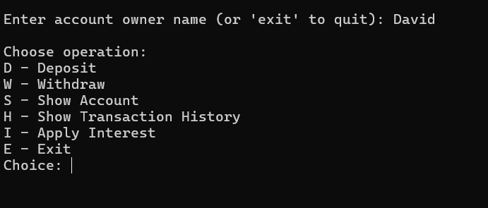

Choose Deposit

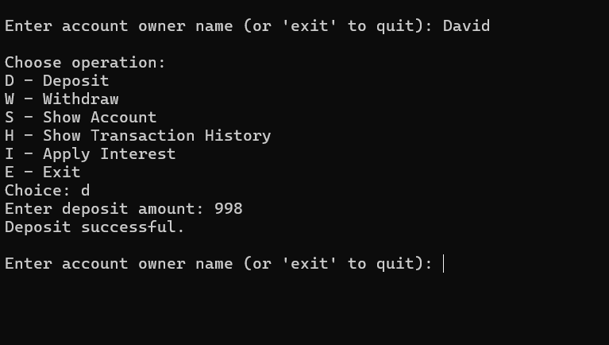

### Choose withdrawal

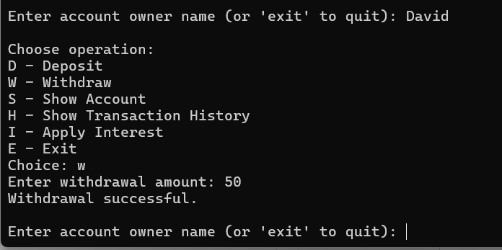

Choose show account

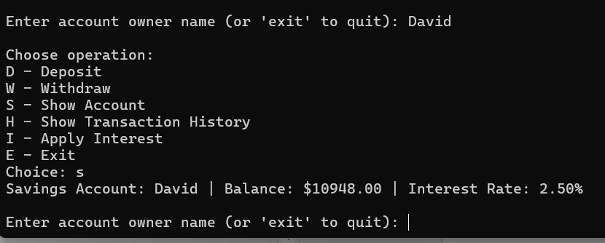

Choose show transaction history

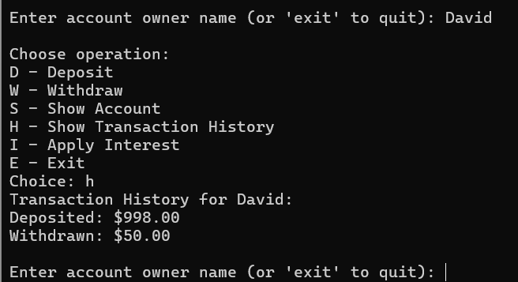

Choose apply interest

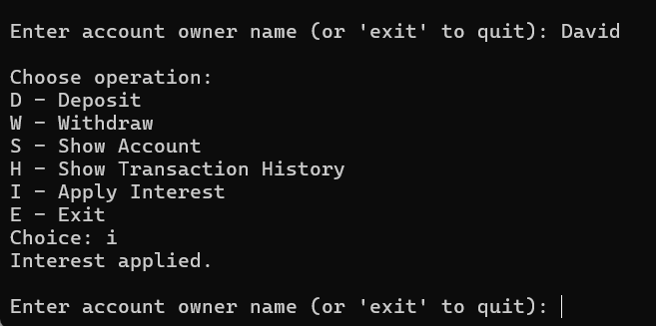

Choose exit

